**Vendor Register**

**Form**:

Header:

1. PO Number field to be added
2. Description & PO# will be filled out automatically once you select add to vendor Register
3. Other fields will be manual entry
4. Mode of Shipment

Under Planned the following fields with the correspondence activity ID’s:

* Production Lead Time
* FCA Date - activity ID
* Shipping Period
* Date on Site - activity ID

Under Forecast the following fields to be added:

* Production Lead Time
* FCA Date = Production Lead Time + Production Lead Time
* Shipping Period
* Date on Site = FCA Date + Shipping Period

Under Actual the following fields to be added:

1. Production Lead Time
2. FCA Date
3. Shipping Period
4. Date on Site
5. PL number

The following functions to be active:

1. Draft
2. PDF & Email
3. Linked to option should be there

Remove:

1. Submission of Supplier
2. Approval of supplier
3. Status

**List Page:**

1. Export To Concerns should be there.
2. Email, PDF & Data Date
3. Transmittal Letter
4. Should be able to Search with PL#, PO#, description. And should
5. Long Lead and others Buttons should be there to filter Items
6. Show Links option should be there

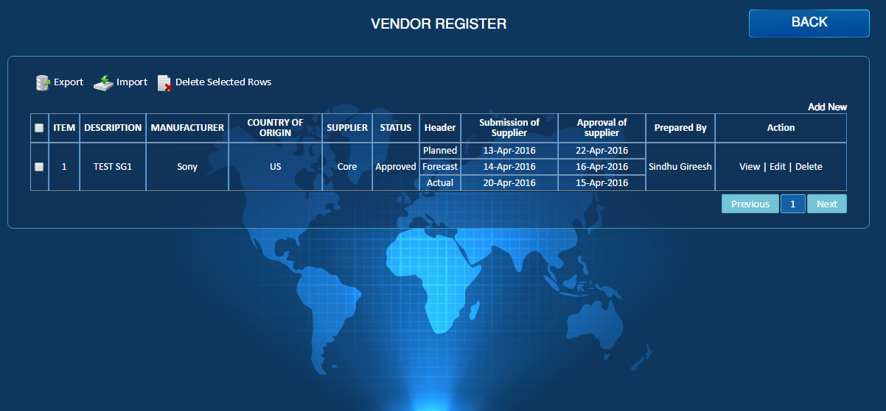

Others

Long Lead

Data Date

Email

Transmittal

PDF

Export to Concerns

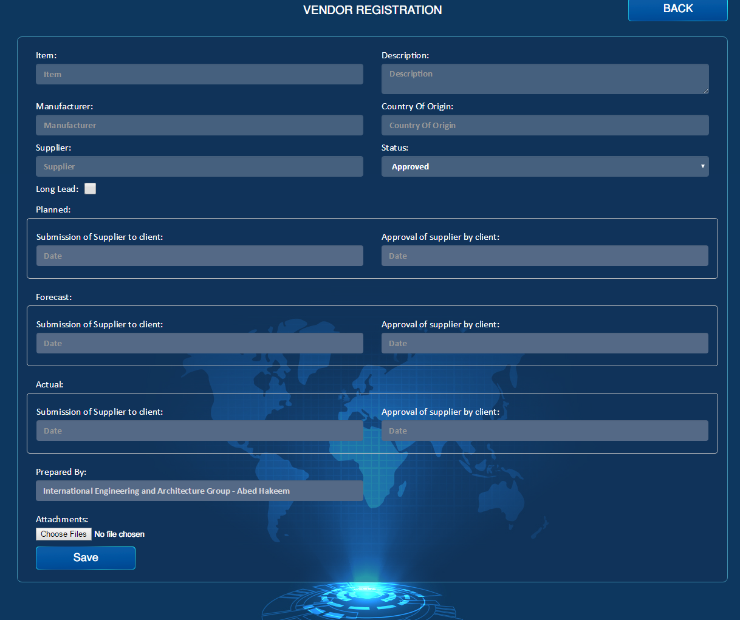

Draft